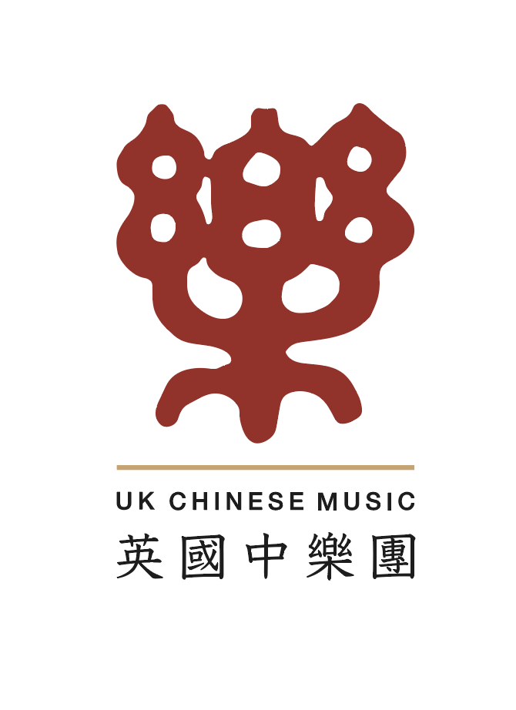 | UK Chinese Music Ensemble and  London Youlan Qin Society 伦敦幽兰琴社  Chinese Music and Calligraphy Courses  17 April – 7 July 2023  Registration form | 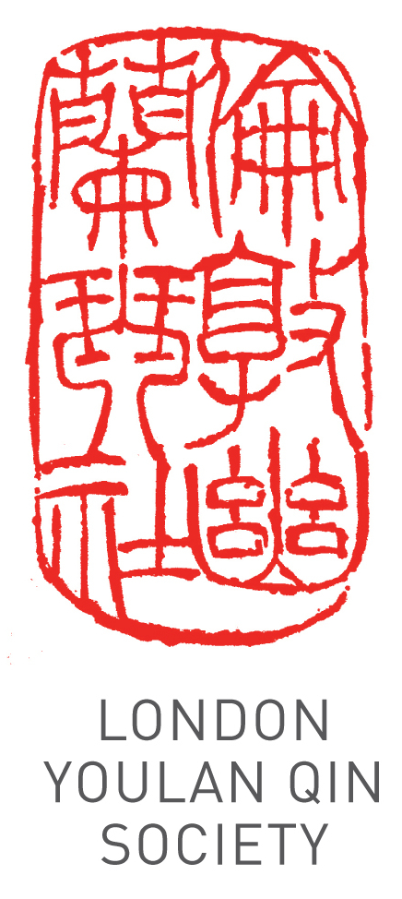
Applicant Details
Title (Dr/Mr/Ms/other):
Name:
Address:
Phone: Email:
Registration Information
Which instrument(s) do you wish to learn? |  | ..................
Do you already play the instrument? |  | Yes |  | No
If so, to what level? | Beginner | Intermediate |  | Advanced
Attendees are strongly encouraged to use their own instrument. A limited number are available for hire, on a first come first served basis. Please tick the box if you need to hire an instrument
Payment
11 weekly group lessons £275 intermediate/advanced, £242 all beginner group classes: £ …….
11 weekly individual 1-to-1 lessons £440 @£40/hour, Level 3 up from 495£ @45£/hour
1-to-2 lessons £330 @£30/hour
6 group calligraphy classes £132; 6 1-to-1 calligraphy classes 240 @£40/hour,
Specify Course(s): …………………………… 10% discount for LYQS/UKCM members: …………
Total £ …….
Bank: HSBC
Account name: China Arts Ltd
Account number: 11440691
Sort Code: 40-20-07
IBAN: GB89HBUK40200711440691
BIC: HBUKGB4129V
Please pay by bank transfer, specifying your name as reference, and email a scan of the transaction. Please make your payment at least two days before your first lesson.
I wish to register for the course.

Signature: ____________________________ Date: ______________________
Please email the completed form and proof of payment (e.g. screen capture of the transaction) to info@ukchinesemusic.com.
Please note that the course fee cannot be refunded if the attendee misses any classes.

