 | London Youlan Qin Society 伦敦幽兰琴社  Chinese guqin and pipa music courses  Tuesdays, 14 January to 31 March 2020  Registration Form | 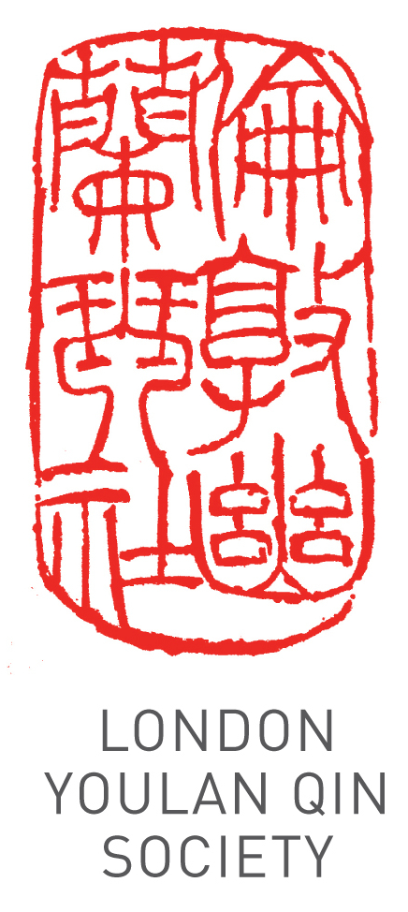
Applicant Details
Title (Dr/Mr/Ms/other):
Name:
Address:
Phone: Email:
Registration Information
Which instrument do you wish to learn? |  | guqin |  | pipa
Do you already play the instrument? |  | Yes |  | No
If so, to what level? | Beginner | Intermediate |  | Advanced
Attendees are encouraged to bring their own instrument. A limited number are available for hire, on a first come first served basis. Please tick the box if you need to hire an instrument

Payment
12 weekly group lessons (£240) £ ……. 12 weekly 1 to 1 or 1 to 2 lessons (£480) £ …….
Time slot: ……………………………
Fees include use of instruments during the classes.
Total £ …….
Account name: China Arts Ltd
Account number: 11440691
Sort Code: 40-20-07
Please pay by bank transfer. Alternatively, make cheques payable to China Arts Ltd and post to Dr Cheng Yu, Guqin and Pipa Courses, London Fo Guang Shan Temple, 84 Margaret St, London W1W 8TD. For bank transfer payments, please specify your name as reference and email a scan of the transaction or bring proof of payment. Please make your payment before 13 January 2020.

I wish to register for the 12 weeks of the course.

Signature: ____________________________ Date: ______________________
Please email the completed form to info@ukchinesemusic.com
Please note that the course fee cannot be refunded if the attendee misses any classes.

